**MISHAN REGMI**

**1841030**

**Python Practice Program LAB 19**

**CODE**

**CANVAS CODE**

from tkinter import *

canvas_width = 500

canvas_height = 150

def paint( event ):

   python_green = "#476042"

   x1, y1 = ( event.x - 1 ), ( event.y - 1 )

   x2, y2 = ( event.x + 1 ), ( event.y + 1 )

   w.create_oval( x1, y1, x2, y2, fill = python_green )

master = Tk()

master.title( "Canvas 1841030" )

w = Canvas(master,

           width=canvas_width,

           height=canvas_height)

w.pack(expand = YES, fill = BOTH)

w.bind( "<B1-Motion>", paint )

message = Label( master, text = "Press and Drag the mouse to draw" )

message.pack( side = BOTTOM )

mainloop()

**MENU CODE**

from tkinter import *

import tkinter.messagebox

root=Tk()

root.geometry('850x550')

root.title("Student Info Center")

root.configure(background="silver")

#Entry widget object

textin=StringVar()

#Dictionaries

exlist={'Mishan':'Developer','Deep':'Designer','Rohan':'Managing Director','Aastha':'Financial Manager','A':'Actor',

        'B':'Baseball Player','C':'Comedian'}

def clk():

     entered = ent.get()

     output.delete(0.0,END)

     try:

          textin = exlist[entered]

     except:

          textin = 'SORRY NO INFO \n AVAILABLE!!!!!!!!\n'

     output.insert(0.0,textin)

def ex():

   tkinter.messagebox.showinfo("Program",'Exit')

   exit()

def exitt():

     tkinter.messagebox.showinfo("Program",'Exit')

     exit()

def me():

     text='\n XYZ \n OKAY \n Nice'

     saveFile=open('text.txt','w')

     saveFile.write(text)

     print('This are the entries::',text)

def hel():

   help(tkinter)

def cont():

     tkinter.messagebox.showinfo("Developed By",'\n 1.Mishan Regmi\n 2.Arjun Adhikari \n')

def clr():

     textin.set(" ")

menu = Menu(root)

root.config(menu=menu)

subm = Menu(menu)

menu.add_cascade(label="File",menu=subm)

subm.add_command(label="Save")

subm.add_command(label="Exit",command=ex)

subm2 = Menu(menu)

menu.add_cascade(label="About",menu=subm2)

subm2.add_command(label="Contributors",command=cont)

lab=Label(root,text='Name :',font=('none 20 bold'))

lab.grid(row=0,column=1,sticky=W)

ent=Entry(root,width=20,font=('none 18 bold'),textvar=textin,bg='white')

ent.grid(row=0,column=2,sticky=W)

but=Button(root,padx=2,pady=2,text='Submit',command=clk,bg='powder blue',font=('none 18 bold'))

but.place(x=100,y=90)

but4=Button(root,padx=2,pady=2,text='Clear',font=('none 18 bold'),bg='powder blue',command=clr)

but4.place(x=220,y=90)

output=Text(root,width=20,height=8,font=('Time 20 bold'),fg="black")

output.place(x=100,y=200)

labb=Label(root,text='Results',font=('non 18 bold'))

labb.place(x=0,y=180)

but1=Button(root,padx=2,pady=2,text='Exit',command=exitt,bg='powder blue',font=('none 18 bold'))

but1.place(x=200,y=470)

root.mainloop()

**SCREENSCOT**

**MENU**

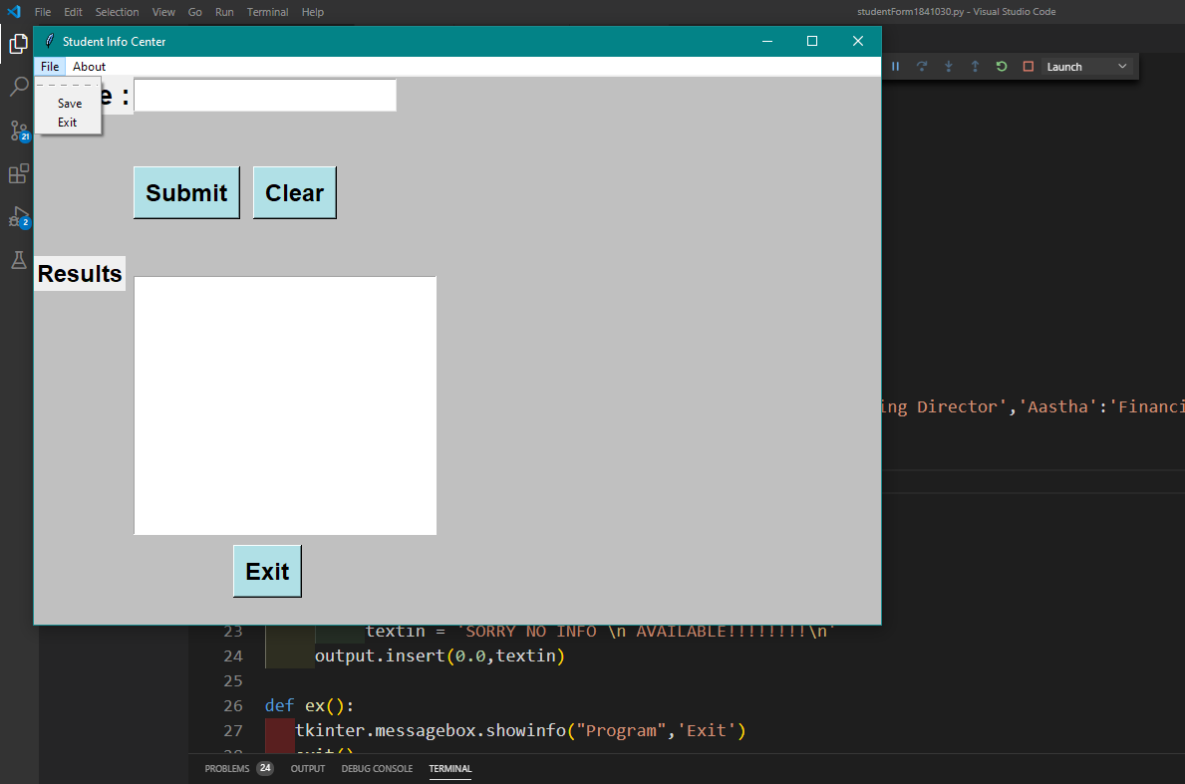

**CANVAS**

